OFFICE ASSISTANT
JOB DESCRIPTION: help with office tasks, like opening and sorting mail or stamping forms with registration location information, etc.

OPENING/SORTING MAIL
- Sign up for Office Assistant volunteer slots on needed days, which are typically weekdays in the middle or end of each month
- Check in with Volunteer Manager at beginning of your shift to get mail that needs to be opened and sorted
- Open envelopes (if there is anything other than forms inside, such as donations or a note, contact Volunteer Manager immediately)
- Envelopes that contain registration forms only:
  - check that Group Code has been stamped on form (if not, stamp with code 000000)
  - staple registration forms to envelope they came in
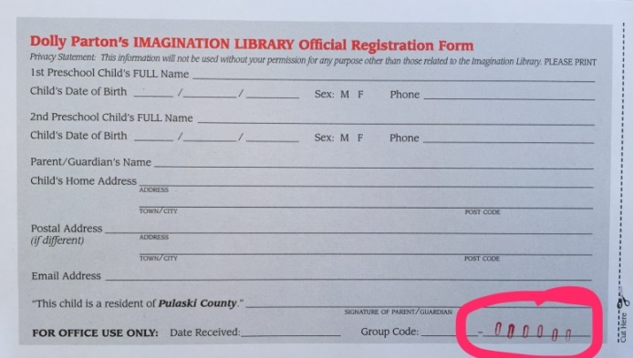

STAMPING REGISTRATION FORMS
- Sign up for Office Assistant volunteer slots on needed days, which are typically weekdays in the middle or end of each month
- Check in with Volunteer Manager at beginning of your shift to get blank registration forms and site forms
- Check that the stamp is on the correct number; adjust as needed
  - TEST the stamp at least once or twice before you start stamping registration forms
  - Stamps use MANUAL ink pads, so you have to stamp the ink pad each time you use the stamp
- Stamp the appropriate number of forms with the Group Code
  - do not push the stamp down too hard or numbers will smear!
- When done, put all forms with the same number back in envelope or box and place site form in front of envelope/on top of box
- Return envelope/box to Volunteer Manager
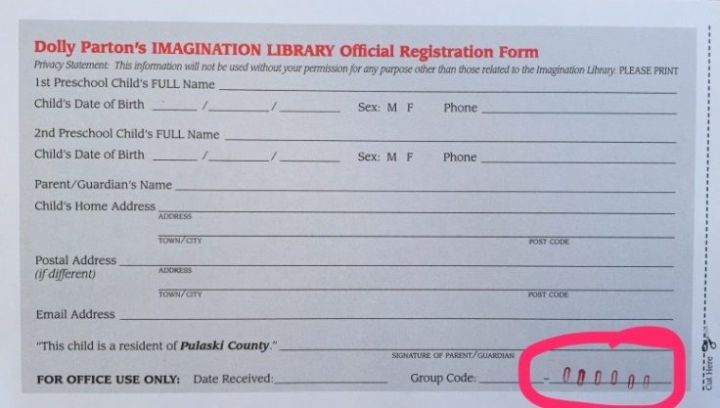

OTHER OFFICE DUTIES
We may have other office needs from time to time, such as helping send thank you letters to donors, filing, scanning forms, etc. Those jobs will be added on an as-needed basis and supervised by the Volunteer Manager.

