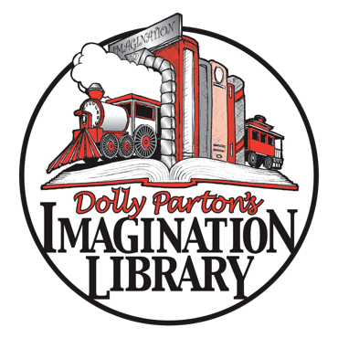
XXXX County Imagination Library
Governance Committee

Overview: The Governance Committee will be responsible for the general governance of [AFFILIATE NAME], including legal documentation, board structure, and general policies and procedures.
Immediate Responsibilities: review Articles of Incorporation and suggest changes; draft Bylaws (including suggested officer positions and terms, board member terms, and term limits for all positions); Secretary of State filings; etc.
Possible Future Responsibilities: conflict of interest policy, board agreement, board member retention and recruitment, new board member orientation and ongoing education, regular review of organizational documents and policies, regular review and revision of board committee structure, performance review of Executive Director
Members:
- NAME
- NAME
- NAME
- NAME

