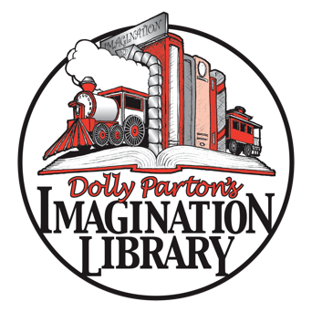

DATE

NAME

ADDRESS

CITY, STATE ZIP

Dear FIRST NAME,

Thank you so much for your generous donation of $_____ that we received on __[date]___. XXXX County Imagination Library strives to create a lifelong love of reading in young children, prepare them for school, and inspire them to dream more, learn more, care more, and be more. Your financial support makes it possible for us to provide developmentally appropriate books to children from birth to age five in XXXX County, completely free of charge!

***Because of your help, we have sent a total of #### books since [START DATE]!***

***It is our goal to mail another #### books in [YEAR]!***

XXXX County Imagination Library is an affiliate of Dolly Parton’s Imagination Library, a nonprofit book gifting program that mails free books to children in participating communities. We sent our first book in [DATE], and we have a goal of sending ***over #### books to kids every month***, reaching 60% of all kids under five in XXXX County by [DATE].

It costs us $$$$ per year to provide each child with one specially selected book per month. With your continued support, we will be able to continue to serve XXXX County’s youngest readers for many years to come.

Sincerely,

[NAME], TITLE