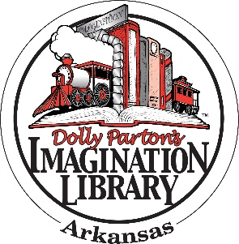

**Frequently Asked Questions**

**Resource for Affiliates**

**Q:** Does my child have to attend ___________ to participate in the Imagination Library?

**A:** No! Any child under the age of five who lives in _________ County is eligible.

**Q:** Can I share this registration form with family and friends?

**A:** Yes! Any eligible child can sign up using this form. You can also sign up online (if affiliate offers online registration).

**Q:** How do I receive books?

**A:** Books will be mailed to your child at the address provided on your child’s registration form.

**Q:** When do books arrive?

A: It takes about 6-8 weeks for your first book to arrive after you return the form. After the first book arrives, you will receive a new book in the mail each month until the month your child turns 5 years old.

**Q:** Do you provide books in languages other than English?

**A:** No, not at this time. However, there are several books each year selected that are bilingual English/Spanish titles.

**Q:** What if I am or my child is blind or visually impaired?

**A:** Dolly Parton Imagination Library has partnered with American Printing House for the Blind, Inc. (APH) to make many of the wonderful books in her program available in braille and audio format for young blind and visually impaired children. You can register for the program here: <http://www.aph.org/dolly-partons-imagination-library/apply/>

**Q:** What if I don’t live in ___________ County?

**A:** __________ County Imagination Library only sends books to kids who live in __________ County. You can check to see if there is an Imagination Library in your area on the main Dolly Parton Imagination Library website: <https://imaginationlibrary.com/usa/find-my-program/>